**Information Gathering Process for a Social Media Dashboard**

1. **Overview of the Project**

The goal of the Social Media Dashboard project is to provide an all-inclusive, user-friendly platform that collects data from many social media networks, including Instagram, Twitter, and Facebook. Businesses will be able to schedule posts, schedule competitor analysis, watch and analyze social media activity in real-time, personalize analytics, and work together as a team using this dashboard. The goal is to improve organizations' online visibility by offering a centralized, effective solution that simplifies social media administration.

**2.0 Problem Statement**

Companies are depending more and more on social media channels to interact with clients and advertise goods and services. But keeping track of several social media profiles on several platforms may be difficult and time-consuming. Managing massive volumes of data, such as comments, likes, shares, and other engagement indicators, can be challenging for businesses. Businesses find it difficult to maintain a consistent social media strategy as a result of this fragmented approach, which results in missed opportunities and inefficiencies in social media administration.

**3.0 Proposed solutions**

The Social Media Dashboard project suggests the following fixes to deal with these issues:

1. Centralized Data Aggregation

Create a dashboard that provides a single, uniform view for data gathered from several social media channels. This would give users a comprehensive picture of all their social media activity and remove the need to go between several networks.

1. Real-Time Monitoring

Provide real-time monitoring tools so that companies can keep track of the most recent conversations and participation on their social media accounts. This guarantees prompt customer service replies and supports proactive social media management.

1. Customizable Analytics

Give users the ability to create and modify analytics reports with tools. Companies are able to customize the statistics to meet their own requirements, which helps them understand their social media performance better and make wise decisions.

1. Competitor Analysis

Provide tools for examining the social media activity of rival businesses. Businesses will be able to benchmark their performance, comprehend industry trends, and create more effective social media strategies thanks to this.

1. Scheduling and Automation

Provide scheduling tools so that companies may organise and schedule their postings on various social media networks. This guarantees a consistent online presence and expedites the process of uploading material.

1. Collaboration Tools

Include tools for collaboration to make teamwork easier. Teams managing social media accounts will be able to work together more effectively and efficiently because to features like task assignment, commenting, and insight sharing.

1. User-Friendly Interface

Create a user interface that is simple to use and intuitive. This guarantees that there won't be a significant learning curve for users to efficiently use the dashboard's capabilities.

1. Scalability and Security

Utilizing cutting-edge web technologies that guarantee scalability and strong security, create the dashboard. This will safeguard sensitive data and meet the expanding needs of enterprises.

**4.1 Method Used**

To gather information for creating a comprehensive social media dashboard, a combination of methods is typically employed:

**Interviews**: Conducting interviews with stakeholders such as marketing managers, social media analysts, and content creators to understand their requirements and pain points.

**Questionnaires**: Distributing questionnaires to a larger audience to gather quantitative data on what metrics and features are most valuable to potential users.

**Observation:** Observing how users interact with existing dashboards and social media analytics tools to identify common workflows, preferences, and challenges.

**API Documentation Review**: Reviewing the API documentation of selected social media platforms to determine the available data points, access methods, and any limitations or rate limits.

**Competitor Analysis:** Analyzing existing social media dashboards and tools to identify best practices and gaps in current offerings.

**4.2 Summary from Methods Used**

Interviews: Through interviews with marketing managers and social media analysts, it was discovered that real-time data and customizable reports are crucial features. For example, a marketing manager at a mid-sized company expressed the need for real-time engagement metrics to quickly adapt their social media strategy.

Questionnaires: A questionnaire distributed to 100 social media professionals revealed that 85% prioritize tracking engagement rates, while 70% find sentiment analysis important. An example response from a social media strategist highlighted the importance of cross-platform comparison metrics to gauge campaign effectiveness.

Observation: Observations of users interacting with current social media analytics tools showed a preference for dashboards that offer drill-down capabilities and visual representations like heatmaps and trend lines. For instance, users frequently accessed detailed post-performance data after viewing summary statistics.

API Documentation Review: Reviewing API documentation for platforms like Facebook and Twitter revealed the availability of data points such as likes, shares, comments, and follower demographics. However, it also highlighted challenges like rate limits and the need for OAuth authentication.

Competitor Analysis: Analysis of competitors' dashboards revealed that while most provide basic engagement metrics, few offer advanced features like predictive analytics or integration with CRM systems. For example, a competitor dashboard lacked comprehensive integration with LinkedIn, limiting its usefulness for B2B marketers.

By combining these methods, we gathered a holistic understanding of user needs, technical requirements, and current market offerings, informing the development of a robust and user-friendly social media dashboard.

**5.1 Current Business Process (Scenarios, Workflow)**

**Scenarios**

**Social Media Manager**: Uses the dashboard to monitor brand mentions, engagement metrics, and sentiment analysis across various social media platforms.

**Marketing Analyst**: Extracts insights and generates reports to inform marketing strategies based on aggregated social media data.

**Customer Service Representative:** Tracks customer complaints and feedback to improve service quality.

**Workflow**

* **Data Collection:** Connects to APIs of various social media platforms (e.g., Facebook, Twitter, Instagram). Retrieves data including posts, comments, likes, shares, and follower statistics.
* **Data Aggregation:** Consolidates data from different platforms into a unified format.

Normalizes metrics for comparative analysis.

* **Data Storage:** Stores aggregated data in a centralized database.

Maintains historical data for trend analysis.

* **Data Analysis:** Performs sentiment analysis on text data. Calculates engagement metrics. Identifies trends and patterns.
* **Reporting and Visualization:** Generates visual reports and dashboards. Provides filtering and drill-down capabilities for detailed analysis.

**5.2 Functional Requirement (Input, Process, and Output)**

**Inputs:**

* Social Media Data: Posts, comments, likes, shares, followers, etc., from multiple platforms.
* User Inputs: Filters, search queries, and preferences for custom reports.

**Processes:**

* Data Extraction: Fetch data using APIs from various social media platforms.
* Data Cleaning: Remove duplicates, handle missing values, and normalize data formats.
* Data Aggregation: Combine data from different platforms into a unified dataset.
* Sentiment Analysis: Analyze text data to determine sentiment polarity.
* Metric Calculation: Compute engagement rates, growth metrics, and other KPIs.
* Report Generation: Create visual dashboards and exportable reports.

**Outputs:**

* Dashboards: Interactive visualizations showing aggregated social media data.
* Reports: PDF/Excel reports summarizing key metrics and insights.
* Alerts: Notifications for significant events or trends (e.g., spike in negative sentiment).

**5.3 Non-functional Requirement (Performance and Control)**

**Performance**

**Scalability:** The system should handle increasing amounts of data as social media activity grows.

**Response Time:** Dashboards and reports should load within 2-3 seconds.

**Data Freshness:** Data should be updated at least every 15 minutes to ensure near real-time insights.

**Control**

**Security:** Ensure secure access to data with authentication and authorization mechanisms.

**Data Privacy:** Comply with regulations such as GDPR, ensuring user data is protected and used ethically.

**Reliability:** The system should have high availability and handle failures gracefully with minimal downtime.

**5.4 Logical DFD AS-IS System (Context Diagram, Diagram 0, Child)**

**Context diagram: -**

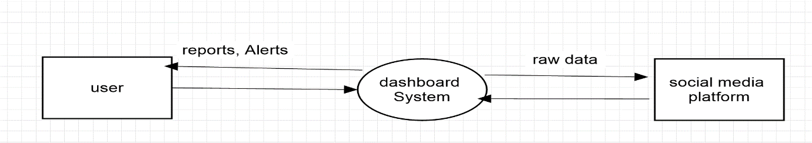

**Diagram 0:-**

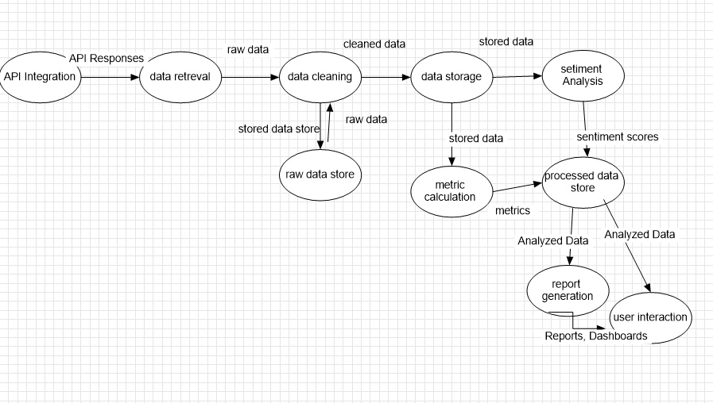

**Child:-**

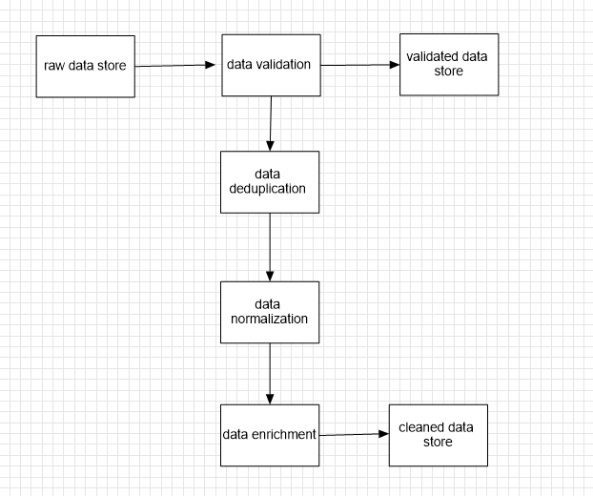

**6.0 SUMMARY**

This project aims to develop a comprehensive dashboard that aggregates data from multiple social media platforms, addressing the inefficiencies faced by social media professionals in tracking and analyzing performance metrics. The dashboard will integrate real-time data, offer customizable reports, and feature advanced analytics capabilities.